[1]

A novel method for bilateral gait segmentation using a single thigh-mounted depth sensor and IMU

Blair H. Hu*, Student Member, IEEE, Nili E. Krausz*, Student Member, IEEE, and Levi J. Hargrove, Member, IEEE

*Abstract*— Lower limb assistive devices have shown potential to restore mobility to millions of individuals with walking impairments. To move towards clinical viability, these devices must show they can be controlled safely and reliably using sensors which are user-friendly. To assist the user’s walking patterns, many devices implement finite-state controllers which rely on accurate estimation of the current gait phase (e.g. stance, swing) of one or both legs. Bilateral gait segmentation is especially important for restoring natural interlimb coordination, which contributes to device safety and efficiency. Most existing techniques for gait segmentation use ground contact, device-embedded, or body-worn sensors with threshold- or machine learning-based algorithms. They have been effective at identifying the state of the ipsilateral (i.e. sensor-side) leg but can become inconvenient for bilateral gait segmentation because they often require many sensors and are more sensitive to sensor placement. Therefore, we present a proof of concept for a novel approach to bilateral gait segmentation using a thigh-mounted IMU and depth sensor with the contralateral leg in its field of view. We extracted two features, ground and shank angle, from the depth data and developed a sensor fusion strategy to predict contralateral heel contact and ipsilateral toe off with accuracy approaching that of a setup with bilateral thigh and shank IMUs. By using computer vision to estimate the state of both legs, we introduce a new technique for bilateral gait segmentation which could make assistive devices more user-friendly, safe, and functional.

# INTRODUCTION

In recent years, the field of wearable lower-limb assistive devices has expanded greatly and there are now many research and commercially available devices which can help restore locomotion. For example, powered prostheses have enabled amputees to seamlessly and intuitively transition between different locomotor activities including level ground, stairs, and ramps [1]–[3]. Also, powered exoskeletons and orthoses have enabled individuals with paresis or paralysis to regain some functional independence by assisting transitions between sitting, standing, and walking on level ground [4], [5]. Because powered devices can be controlled to actively change their mechanical properties between different locomotor activities and can inject energy into the system (*e.g.* powered plantarflexion), they have already demonstrated impressive potential towards improving walking kinematics and overall mobility [6], [7]. However, for powered devices to gain acceptance outside of the lab environment it is necessary to show that they can be controlled safely, reliably, and intuitively using sensors which are both comfortable and convenient for users.

There are a variety of approaches for controlling wearable lower-limb assistive devices for ambulation but gait phase-based methods such as finite-state controllers have been most popular. Finite-state controllers decompose gait into a series of distinct phases and parameterize the control laws based on the current state (*e.g.* stance, swing). The number and type of states are arbitrary depending on the application and available sensors but finite-state controllers have been used successfully to control many devices for several activities [8]. The first step, though, to appropriately selecting and executing a control law within a finite-state paradigm is state estimation (*i.e.* identifying the current phase of gait).

Although most unilateral devices only estimate the state of the assisted side, bilateral state estimation is important for restoring safe and natural interlimb coordination. For instance, robust identification of the double support phase could help ensure a device does not become compliant before weight transfer, which may lead to buckling and a potential fall. Accurate detection of the beginning and end of the double support phase could also make assistance (*e.g.* powered plantarflexion) more effective by coordinating the timing of power delivery. Thus, accurate bilateral gait segmentation can contribute to safe, reliable, and intuitive control of a device by synergistically assisting instead of inadvertently disrupting the user’s locomotion.

Many techniques have already been developed for gait segmentation using a variety of body-worn and device-embedded sensors and detection algorithms [9]. For example, axial load and joint kinematics are used to transition between stance and swing states for a powered knee-ankle prosthesis [1]. Foot switches and pressure sensitive insoles are also commonly used to derive a ground contact signal which can be used to control assistive devices. However, load cells are expensive and primarily useful for prosthesis applications, while ground contact sensors are sensitive to placement (based on foot size and pressure distribution) and require a foot plate or shoe insert. Alternatively, electromyographic (EMG) signals have been used to detect up to 8 sub-phases of gait but muscle signals are inherently more variable and instrumentation can be uncomfortable and inconvenient [9]. Finally, linear accelerometers, gyroscopes, and inertial measurement units (IMU) have also been used for gait segmentation, sometimes in combination with ground contact sensors. Inertial sensors can conveniently and robustly estimate the state of the instrumented limb using algorithms based on peak detection and threshold crossings. However, indirectly identifying the state of the uninstrumented leg poses challenges for these gait segmentation approaches. Therefore, most unilateral assistive devices lack awareness of the state of the unassisted leg, limiting their ability to coordinate their behavior between both legs.

There are several ways to perform gait segmentation of both legs, including direct instrumentation (with IMU’s and/or ground contact sensors placed on the unassisted leg) or indirect sensing. In this paper, we present a novel indirect sensing strategy by fusing data from unilateral thigh-mounted IMU and depth sensors. With appropriate positioning and computer vision techniques, we can sense not only the environment but also the contralateral leg and its interaction with the environment. Because vision is a unique source of high-confidence information, one might suspect it would improve gait segmentation. Previously, a few studies have demonstrated the potential of using vision to detect changes in terrain to improve intent recognition [11]–[13]; however, to the best of our knowledge the use of a leg-mounted depth sensor for gait segmentation is unprecedented.

We present a proof of concept for a unilateral sensor fusion approach that provides accurate and robust detection of bilateral gait events. We demonstrate that using depth sensor data to extract additional contextual information about the contralateral leg and the environment improves bilateral gait segmentation. Our initial findings show that vision is a robust, non-redundant, and modular sensor modality that could improve the control of lower limb assistive devices.

# Methods

## A. Instrumentation and protocol

This study was carried out on one subject (male, 27 years old, 183 cm, 73 kg) after obtaining written informed consent in accordance with a protocol approved by the Northwestern University Institutional Review Board. The subject was instrumented with 6-DOF (tri-axial accelerometer and gyroscope) IMUs placed bilaterally on the thigh and shank and sampled at 500 Hz (MPU-9250; Invensense, San Jose, CA, USA). The sensors were attached to the subject with elastic straps and cohesive bandage. A 3D time-of-flight camera (Pico Flexx; Pmd Tech, Siegen, Germany [14]) was secured to the right thigh with Velcro (adjacent to the IMU, internally rotated by ~10 degrees and tilted toward the ground by 30 degrees) (Figure 1). The camera was positioned such that the left (contralateral) leg was visible during walking. The frame rate and resolution of the camera were set to 15 fps and 171x224 pixels, respectively.

Although ground contact sensors and embedded force platforms are commonly used to collect ground truth measurements of gait events, we chose to use an IMU-based segmentation approach. This approach searches for peaks in the sagittal plane gyroscopic signal from the shank-mounted IMUs [15]. Previously, IMU-based segmentation approaches have been validated against more traditional techniques and are less sensitive to sensor placement [16]. We also chose not to use a walkway with embedded force platforms so the subject could walk freely and vary his path. The subject completed a total of 14 trials by performing two repetitions of each condition for three types of walking activities: (1) straight line walking at slow, normal, or fast speed for 10 meters, (2) straight or zig-zag walking at normal speed for 10 meters with obstacles in the path, and (3) straight line walking followed by a 90° right or left hand turn at normal speed for 15 meters. The wearable sensors were used in a tethered setup and instrumentation took about 15 minutes.

## B. IMU pre-processing

IMU signals were low-pass filtered (6th order, Butterworth) at 25 Hz. The estimated thigh and shank orientation angles (relative to vertical) were calculated using a complementary filter. To determine ground truth labels for the gait phase (stance or swing) of each leg, we applied an algorithm that looks for peaks and threshold crossings in the sagittal plane angular velocity signal from the shank IMU. Briefly, midswing events were identified as the maximum peaks in the angular velocity signal. Toe off events were identified as the minimum peaks immediately before midswing events and heel contact events were identified as the first zero-crossings after the preceding midswing events.

|  |  |
| --- | --- |
|  | Figure 1. Sensor schematic. IMUs were positioned bilaterally on the thigh and shank, and a single depth sensor was positioned on the right thigh. Shown are isometric and side views of a single frame of raw depth data with the left foot visible, as well as raw angular velocity and acceleration data from the right thigh IMU during a single walking trial. |

## C. Depth sensor pre-processing

Depth data frames were converted to 171x224x3 point clouds. Next, point clouds were denoised to remove outliers beyond a threshold of 5 cm, and downsampled using a grid filter with a step size of 1 cm for computational efficiency. The 2D projection of the depth data was also used to provide additional context for the left leg segmentation.

*Right leg:* Although the right leg is not in the camera’s field of view, information about the movement of the environment (*i.e.* ground plane) can be used for gait segmentation. During stance, the leg rolls over the foot; thus, changes in leg orientation result in rotation of the environment relative to the global reference frame. This rotation can be used to estimate whether the right leg is in stance or swing (Figure 2). We first had to remove the initial rotation of the environment because the sensor was tilted toward the ground by 30°. This angle was determined from the orientation of the ground during the standing period at the beginning of each trial. We used an affine transform based on the Euler angle rotation matrix to remove this initial offset from the original point clouds. Next, RANSAC [17] was used to fit a plane to the points within a region of interest (ROI) immediately in front of the user. The angle of this plane relative to horizontal (ground angle), **θ**, was used for detecting right toe off events.

*Left leg:* The left leg was in the field of view, but only visible when the left leg was leading. We used **θ** to remove the ground plane from the point cloud and its 2D projection. Next, we sequentially applied morphological thickening, closing, and hole filling to isolate distinct regions in the remaining 2D projection. We performed connected component labeling (CCL) on all remaining regions in the 2D projection. Any regions between 500 and 10,000 pixels within a ROI were defined as the shank. We fit a border to the shank pixels and used linear regression to find the line through the centroid (Figure 2). The angle of this line (shank angle), **φ**, was used for detecting left heel contact events.

## 

Figure 2. Depth pre-processing flowchart. The raw depth data and 2D projection were used to produce an estimate of the ground angle (θ) and shank angle (φ) to estimate the right toe off and left heel contact, respectively.

*D. Gait event prediction*

The IMU and depth data were first temporally aligned by upsampling the depth data to match the IMU’s sampling rate of 500 Hz. Next, the data were partitioned into 300 ms sliding windows (30 ms increment) to match current standards for online control of a powered leg prosthesis using intent recognition [1]. The ground truth (stance or swing) for each window was defined as the final label of the window. We implemented two independent methods using IMU signals only or depth data only to identify left heel contact (LHC) and right toe off (RTO). Assuming a unilateral assistive device were worn on the right leg, LHC and RTO would represent the critical events spanning the double support phase of interest. Leave-one-out cross-validation was performed by training on the windows from all but one trial. We quantified the accuracy of detecting LHC and RTO by averaging the residuals between classifier predictions and the ground truth for all steps, excluding the first and last steps (*i.e.* gait initiation and termination) for each trial. If LHC was detected more than 400 ms after the corresponding ground truth or RTO was detected more than 600 ms after the corresponding ground truth, the event was reported separately as an outlier and not included in the average.

*IMU only:* We compared the residuals of LHC and RTO predictions for different combinations of sensors including right thigh IMU only (R Thigh), right thigh and shank IMUs (R Thigh + Shank), and bilateral thigh and shank IMUs (R/L Thigh + Shank). Six features (mean, standard deviation, maximum, minimum, initial value, final value) were extracted from each window for each IMU channel (tri-axial accelerometer, tri-axial gyroscope, calculated orientation angle) for a total of 42 features per IMU sensor. These heuristic features were chosen because they are typically used in intent recognition for prosthesis control [1]. Features were normalized to have zero mean and unit variance and the dimensionality was reduced using principal components analysis (PCA) to 25 components, which accounted for more than 99 percent of the total variance (Figure 3). We used either linear discriminant analysis (LDA) or support vector machine (SVM) with Gaussian kernel as the classifier and used the estimated probability of each class (stance or swing) to make predictions for each window.

*Depth sensor only:* We used a template matching method to estimate the probability of detecting RTO and LHC. First, we created templates for RTO and LHC by averaging the windows immediately preceding each ground truth gait event in the training data. For each feature, we then applied element-wise multiplication between each sliding window and the corresponding template. Next, we applied a binary mask to the element-wise product such that a one was output for each point in the sliding window where the feature and template had matching signs. Lastly, the probability of detecting a gait event in each window was estimated by averaging the binarized signal over the window length, which yielded a value between 0 and 1 (Figure 3).

After tuning, a probability threshold of 0.55 was set to identify a range of possible windows for detecting a gait event. Empirically, the range of possible LHC windows tended to be centered near the ground truth; therefore, LHC was predicted as the window corresponding to highest probability (Figure 4). The range of possible RTO windows tended to end near the ground truth; therefore, RTO was predicted as the last window (Figure 4).

*Sensor fusion:* To perform sensor fusion, we computed an equally weighted average of the probabilities of each event from the IMU and the depth sensor. After tuning, a threshold of 0.55 was applied to the averaged probability to identify a range of possible windows for detecting gait events based on sensor fusion (Fused). Empirically, the range of possible LHC and RTO windows tended to begin near the corresponding ground truth; therefore, LHC and RTO were predicted as the first window in their respective range of windows (Figure 4).

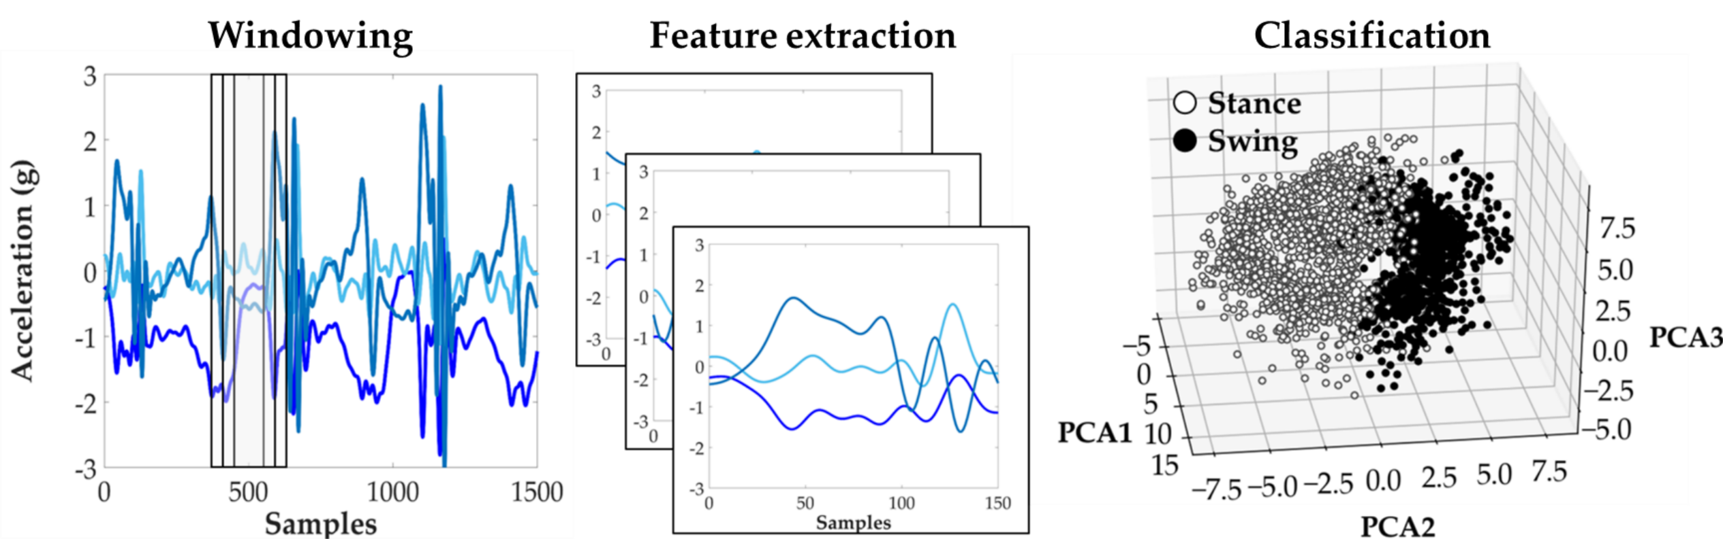

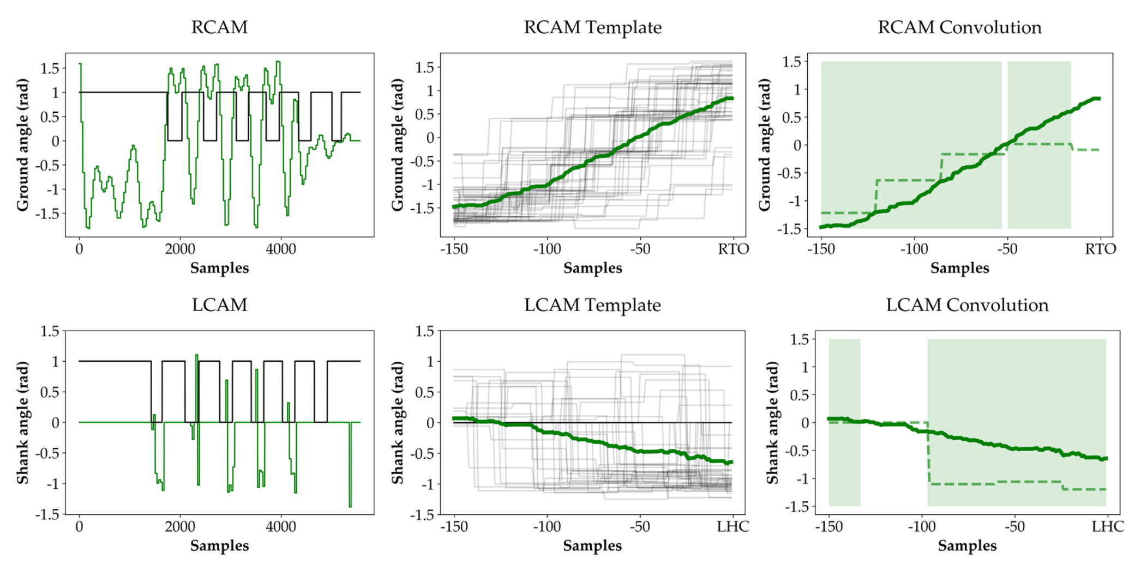

Figure 3. Estimating gait event probabilities. (Top row) IMU signals were partitioned into 300 ms windows, from which features were extracted. PCA was used to reduce the dimensionality to 25 and an LDA or SVM classifier was fit to predict stance or swing. (Middle, bottom row) The ground truth state, stance (1) or swing (0) is represented by the black trace. Shank and ground angle were partitioned into 300 ms windows (dashed green line) and mutiplied element wise by their corresponding templates (solid green line). The output was converted to a probability by averaging the binarized signal (green shaded region).

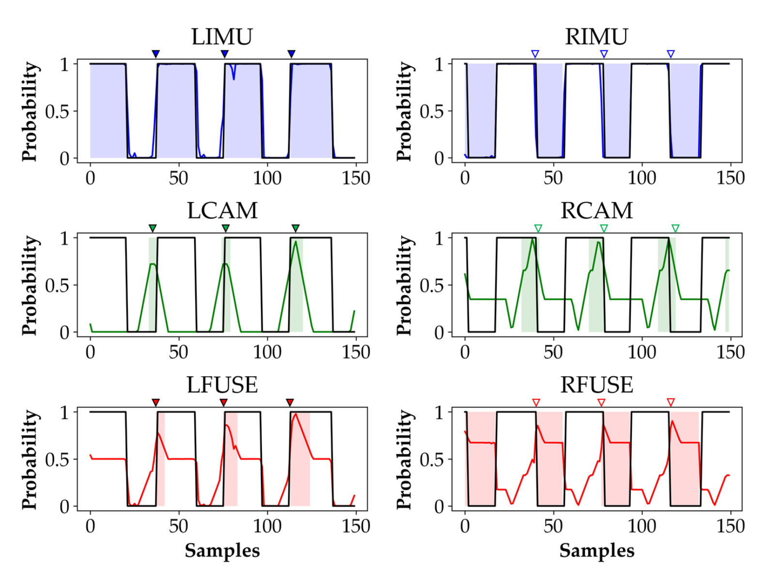

Figure 4. Gait event prediction. The shaded regions represent the range of possible windows for detecting a gait event using R Thigh (RIMU), depth sensor only (RCAM), or both (RFUSE). The tick marks represent the final predictions for LHC (filled) and RTO (empty). The colored traces represent the probability estimates.

# Results

Results for LDA, which outperformed SVM, are presented in Tables I and II. The residuals for SVM predictions of LHC were -34 ± 96 ms (mean ± S.D.) with no outliers and -16 ± 63 ms with 2 outliers for R Thigh and Fused, respectively. The residuals for SVM predictions of RTO were 7 ± 30 ms with one outlier and 13 ± 60 ms with no outliers for R Thigh and Fused, respectively. Predictions for RTO were generally more accurate than for LHC when using right leg sensors only, in terms of mean and standard deviation. The average residuals were also mostly negative, meaning that events were predicted before the ground truth occurrence. Compared to predictions made using IMU sensors only, predictions with the depth sensor only had larger variability. There were also more outliers for LHC when using the depth sensor only, but outliers were reduced with sensor fusion. Unilateral sensor fusion slightly improved prediction accuracy compared to R Thigh, and approached the accuracy of R/L Thigh + Shank.

# Discussion

In this work, we developed a novel approach for bilateral gait segmentation using a single IMU and depth sensor, both worn unilaterally on the right thigh. Our approach independently detects left heel contact and right toe off events from sliding windows using the IMU only, depth sensor only, or both sensors together. The IMU-based prediction relied on either an LDA or SVM classifier trained with heuristic features. For the depth-based prediction, we extracted features from the environment and left leg (which are both in the field of view) and implemented a template matching algorithm to assign a probability of detecting a gait event to each sliding window. We fused the predictions using an equally weighted average of the IMU- and depth-based probabilities. We computed the mean and standard deviation of the residuals between our predicted events and the ground truth.

1. Residuals of LHC Predictions

|  | Number of steps = 57 | | |
| --- | --- | --- | --- |
| Mean (ms) | S.D. (ms) | Outliers |
| R Thigh | -23 | 69 | 0 |
| R Thigh + Shank | -8 | 56 | 0 |
| R/L Thigh + Shank | -4 | 30 | 0 |
| Camera | 3 | 106 | 10 |
| Fused | -13 | 61 | 3 |

1. Residuals of RTO Predictions

|  | Number of steps = 54 | | |
| --- | --- | --- | --- |
| Mean (ms) | S.D. (ms) | Outliers |
| R Thigh | -6 | 41 | 0 |
| R Thigh + Shank | 1 | 42 | 0 |
| R/L Thigh + Shank | -9 | 42 | 0 |
| Camera | -7 | 85 | 0 |
| Fused | -5 | 39 | 0 |

We found that our approach accurately detected both events (usually before the ground truth) for a variety of level ground walking tasks which included different speeds and paths. Without any additional adjustments, we did not notice any task-related changes in performance. As expected, we detected the ipsilateral (*i.e.* sensor side) toe off events more accurately than the contralateral heel contact events. Because the subject’s interlimb coordination was intact, we also expected the prediction accuracy for left heel contact events using right leg IMUs to not deteriorate drastically. The classifiers trained with heuristic features from the IMU only learned to associate right thigh kinematics with left leg state; however, we would expect this association to weaken for subjects with gait impairments. Somewhat surprisingly, the depth sensor achieved low mean residuals for both gait events using only one depth-based feature for each prediction. Not surprisingly, there was greater variability and more outliers using the depth sensor alone for two main reasons.

First, we chose not to include the IMU into our estimate of the ground plane, which affected the segmentation of the contralateral foot. Because the outline of the foot was often sparse or absent after ground removal, we chose to estimate heel contact using shank angle. Shank angle served as a convenient proxy for detecting heel contact because it is related to foot rollover but it is only indirectly related to ground contact. The estimate of shank angle could have also been affected by movement of the sensor during walking and thresholding applied during image processing.

Second, the template matching procedure was sensitive to temporal misalignment and the binary masking operation did not always adequately reflect the similarity between the sliding window and template. We also found that sensor fusion slightly improved prediction accuracy and approached the accuracy with bilateral shank and thigh IMUs. Because predicting gait events using depth data makes no assumptions about interlimb coordination, we expected sensor fusion to improve prediction accuracy. We believe this is an important finding because it demonstrates that unilateral sensor fusion can achieve similar accuracies as a bilateral setup.

## Limitations and Future Work:

Although our proof of concept provided promising results, we identified several limitations to this work. One limitation is that we only tested our algorithm using a limited number of level ground walking trials. We anticipate that some modifications, particularly to the ground and leg segmentation steps, may be necessary to adapt this algorithm for use with other walking activities such as ascending/descending stairs/ramps. We also excluded gait initiation and termination steps because their kinematics differ from steady state steps. Thus, a separate classifier may be required for accurately segmenting non-steady-state steps.

Our work is also limited by having only one able-bodied subject. In the future, we plan to assess the generalizability of our method to individuals with gait impairments, to a larger collection of walking data (from one subject), and to subject-independent prediction (*i.e.* train and test on different subjects). We expect gait segmentation using unilateral IMU sensors to degrade for subjects with gait impairments or asymmetries, especially for identifying contralateral heel contact. Therefore, we expect the value of depth data for gait segmentation to be even more pronounced when the assumption of intact interlimb coordination is violated.

We also propose several changes to the setup, protocol, and image processing. We did not use an independent sensor modality to acquire the ground truth for heel contact and toe off events for convenience. In the future, a force sensing resistor (FSR) could be used to provide an alternative estimate of the ground truth. We could also test our depth-based algorithm in different environments to determine its robustness to clutter and differently situated environments but our algorithm seemed to perform well even when obstacles were in the field of view.

Adding the pitch estimate from the thigh IMU to our calculation of the ground plane could have improved our segmentation and preserved more of the foot. Adjusting the frame rate and orientation of the depth sensor could have also improved accuracy if they had been optimized to improve the spatiotemporal resolution and field of view. In this work, we only tested one configuration (frame rate, resolution, position), which may not have been optimal for gait segmentation. Also, the positioning of the sensor on the thigh may not be ideal because it would not allow users to wear long pants or skirts. In the future, we will consider other positions that can capture both the environment and contralateral leg in the field of view. Additionally, these results present the possibility of using a single integrated sensor in the future, which would make setup more user-friendly. For instance, several smartphones that include a depth sensor and accelerometers and gyroscopes have been recently released, such as the Lenovo Phab 2 Pro [18] and Asus Zenfone AR [19]. In the future we may explore the use of one of these integrated sensors for gait segmentation.

We believe our approach for gait segmentation may be especially valuable to users of powered assistive devices, because it would provide an additional safeguard during walking by ensuring that the subject is in double support phase before the device becomes compliant and transitions to swing phase. To validate the feasibility of our technique for powered prostheses, we will also replicate our protocol with individuals (including amputees) walking with a powered knee-ankle prosthesis. Our approach may also be relevant to coordinating the behavior of two different unilateral devices which do not share sensors. Additionally, we will evaluate the use of the depth-based features for intent recognition. We believe that the features used for gait segmentation (or others related to the position of the contralateral leg in space and its interaction with the environment) may also be beneficial for predicting the upcoming locomotor activity. For instance, the angle of the shank and height of the foot will likely differ across level ground walking, stair ascent and ramp ascent. Our overall goal will be to develop a system that performs gait segmentation and intent recognition in parallel. Finally, our future work will focus on online implementation of this system and integration with a powered prosthesis.

# Conclusion

We developed a novel approach to bilateral gait segmentation based on a single IMU and depth sensor to predict right toe off and left heel contact events, which represent the beginning and end of a double support phase. The results of our proof of concept showed that predictions based on unilateral IMU and depth-based information approached the accuracy of using bilateral shank and thigh IMUs. By extending the use of depth data beyond environmental sensing to gait segmentation we provide an alternative strategy for sensing the state of both legs using wearable sensors, which could make assistive devices more user-friendly and improve their performance.

Acknowledgment

We thank Eric Earley for his help with the template matching algorithm and for the Whole Foods gift cards.

References

[1] A. M. Simon, K. A. Ingraham, J. A. Spanias, S. Member, A. J. Young, S. B. Finucane, E. G. Halsne, and L. J. Hargrove, “Delaying Ambulation Mode Transition Decisions Improves Accuracy of a Flexible Control System for Powered Knee-Ankle Prosthesis,” *IEEE Trans. Neural Syst. Rehabil. Eng.*, vol. 25, no. 8, pp. 1164–1171, 2017.

[2] J. A. Spanias, A. M. Simon, S. B. Finucane, and E. J. Perreault, “Online adaptive neural control of a robotic lower limb prosthesis,” *J. Neural Eng.*, vol. 15, 2018.

[3] H. Huang, F. Zhang, S. Member, L. J. Hargrove, Z. Dou, D. R. Rogers, K. B. Englehart, and S. Member, “Continuous Locomotion-Mode Identification for Prosthetic Legs Based on Neuromuscular – Mechanical Fusion,” vol. 58, no. 10, pp. 2867–2875, 2011.

[4] H. A. Quintero, R. J. Farris, and M. Goldfarb, “A Method for the Autonomous Control of Lower Limb Exoskeletons for Persons with Paraplegia,” *J. Med. Device.*, vol. 6, no. 4, p. 410031, 2012.

[5] A. J. Young and D. P. Ferris, “State of the Art and Future Directions for Lower Limb Robotic Exoskeletons,” *IEEE Trans. Neural Syst. Rehabil. Eng.*, vol. 25, no. 2, pp. 171–182, 2017.

[6] B. E. Lawson, A. Huff, S. Members, and M. Goldfarb, “A Preliminary Investigation of Powered Prostheses for Improved Walking Biomechanics in Bilateral Transfemoral Amputees,” *Int. Conf. IEEE EMBS*, pp. 4164–4167, 2012.

[7] K. A. Ingraham, N. P. Fey, A. M. Simon, and L. J. Hargrove, “Assessing the Relative Contributions of Active Ankle and Knee Assistance to the Walking Mechanics of Transfemoral Amputees Using a Powered Prosthesis,” *PLoS One*, pp. 1–19, 2016.

[8] M. R. Tucker, J. Olivier, A. Pagel, H. Bleuler, M. Bouri, O. Lambercy, J. D. R. Millán, R. Riener, H. Vallery, and R. Gassert, “Control strategies for active lower extremity prosthetics and orthotics: a review.,” *J. Neuroeng. Rehabil.*, vol. 12, no. 1, pp. 1–29, 2015.

[9] J. Taborri, E. Palermo, S. Rossi, and P. Cappa, “Gait Partitioning Methods : A Systematic Review,” *Sensors*, vol. 16, no. 66, pp. 40–42, 2016.

[10] M. R. Tucker, J. Olivier, A. Pagel, H. Bleuler, M. Bouri, and O. Lambercy, “Control strategies for active lower extremity prosthetics and orthotics : a review Control strategies for active lower extremity prosthetics and orthotics : a review,” *J. Neuroeng. Rehabil.*, vol. 12, no. 1, pp. 1–29, 2015.

[11] N. E. Krausz, T. Lenzi, and L. J. Hargrove, “Depth sensing for improved control of lower limb prostheses,” *IEEE Trans. Biomed. Eng.*, vol. 62, no. 11, pp. 2576–2587, 2015.

[12] M. Liu, D. Wang, and H. Huang, “Development of an Environment-Aware Locomotion Mode Recognition System for Powered Lower Limb Prostheses,” *IEEE Trans. Neural Syst. Rehabil. Eng.*, vol. 4320, no. c, pp. 1–1, 2015.

[13] Y. Massalin, S. Member, M. Abdrakhmanova, A. Varol, and S. Member, “User-Independent Intent Recognition for Lower-Limb Prostheses Using Depth Sensing,” *IEEE Trans. Biomed. Eng.*, vol. 9294, no. c, 2017.

[14] PMD, “Camboard Pico Flexx.” [Online]. Available: http://pmdtec.com/picofamily/.

[15] H. F. Maqbool, M. A. B. Husman, M. I. Awad, A. Abouhossein, P. Mehryar, and N. Iqbal, “Real - time gait event detection for lower limb amputees using a single wearable sensor *,” *Int. Conf. IEEE EMBS*, pp. 5067–5070, 2016.

[16] J. M. Jasiewicz, J. H. J. Allum, J. W. Middleton, A. Barriskill, P. Condie, B. Purcell, R. Che, and T. Li, “Gait event detection using linear accelerometers or angular velocity transducers in able-bodied and spinal-cord injured individuals,” *Gait Posture*, vol. 24, pp. 502–509, 2006.

[17] M. Fischler and R. Bolles, “Random sample consensus: a paradigm for model fitting with applications to image analysis and automated cartography,” *Commun. ACM*, vol. 24, no. 6, 1981.

[18] Lenovo, “Phab 2 Pro,” 2018. [Online]. Available: https://www3.lenovo.com/us/en/smart-devices/-lenovo-smartphones/phab-series/Lenovo-Phab-2-Pro/p/WMD00000220.

[19] Asus, “Zenfone AR,” 2018. [Online]. Available: https://www.asus.com/us/Phone/ZenFone-AR-ZS571KL/.

1. **\*B. H. Hu and N. E. Krausz contributed equally to this work.**

   H. Hu was supported by USSOCOM Contract No. H92222-16-C-0111 and N. E. Krausz was supported by NIH T32 PRND Training Grant.

   B. H. Hu, N. E. Krausz, and L. J. Hargrove are with the Center for Bionic Medicine at the Shirley Ryan AbilityLab (formerly RIC), Chicago, IL 60611 USA, and the Department of Biomedical Engineering, Northwestern University, Evanston, IL 60208 USA (corresponding: [blairhu@u.northwestern.edu](mailto:blairhu2014@u.northwestern.edu), [nilikrausz2013@u.northwestern.edu](mailto:nilikrausz2013@u.northwestern.edu)).

   L. J. Hargrove is also with the Department of Physical Medicine and Rehabilitation at Northwestern University, Evanston, IL 60208 USA.